Advanced Engineering Mathematics, by Erwin Kreyszig 10th. Ed.

**Problem Set 7.7**

No. 1

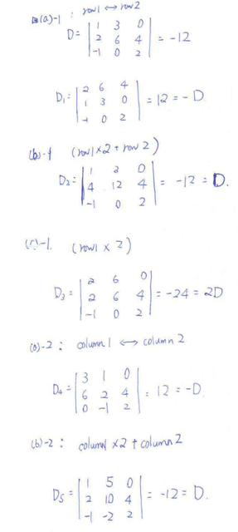



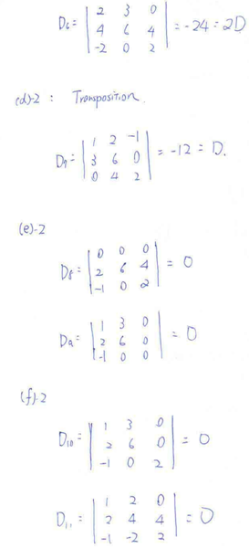

No. 2

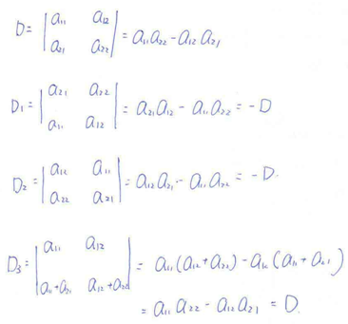

No. 3

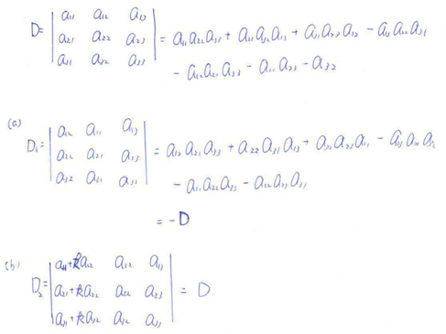

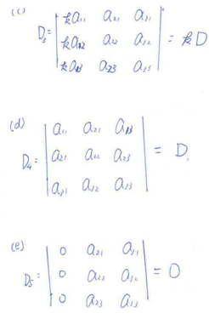

No. 4

問答題或證明題，不解

No. 5

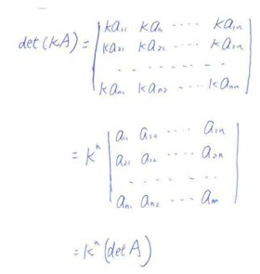

No. 6

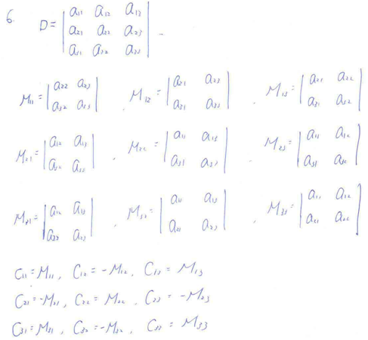

No. 7

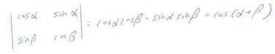

No. 8

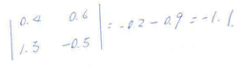

No. 9

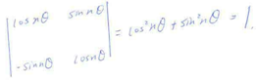

No. 10

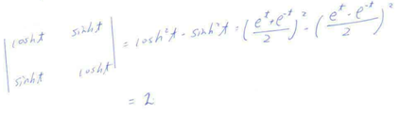

No. 11

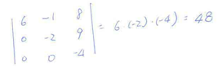

No. 12

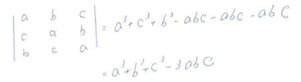

No. 13

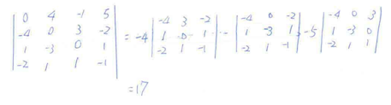

No. 14

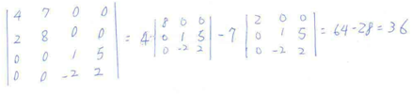

No. 15

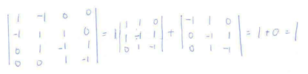

No. 16



No. 17

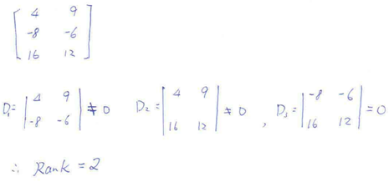

No. 18



No. 19

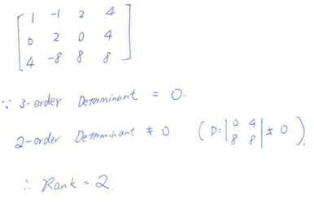

No. 20





No. 21

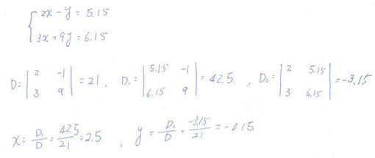

No. 22



No. 23

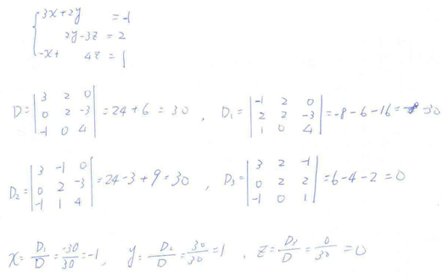

No. 24



No. 25

